3.4.2 Test Results and Validation
Testing results show that the prototype behaves consistently and predictably across all defined scenarios:
- For valid customers with acceptable eligibility, the system produced risk classifications and interest rates that matched benchmark policy outcomes.
- For customers with adverse indicators (e.g. delinquent accounts), the system correctly generated negative or conditional recommendations.
- For non-Singaporean customers without PR status, the system rejected applications regardless of credit score, demonstrating correct enforcement of override rules.
- For unknown customer IDs, the system returned “no information found” responses and did not fabricate loan data, confirming resistance to hallucination.
All observed outputs matched the expected results defined prior to testing, demonstrating decision accuracy and policy compliance.

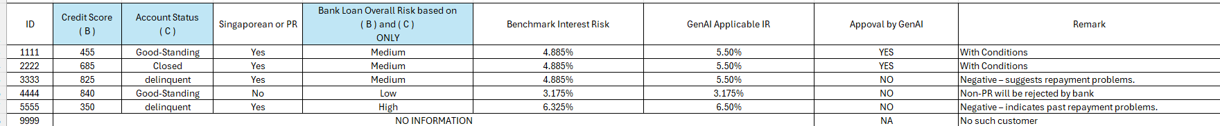
Table 3.4.2 - 1 Summerize Table for GenAI System Testing
The testing and validation process satisfies the highest evaluation band by demonstrating:
- Clear and systematic testing methodology
- Multiple test cases covering normal, edge, and failure scenarios
- Explicit comparison between expected and actual results
- Validation of GenAI reliability and anti-hallucination behaviour
- Evidence of consistent and policy-aligned outputs
Screen captures of test cases/evaluation of our Prototype application:
Customer 1111:
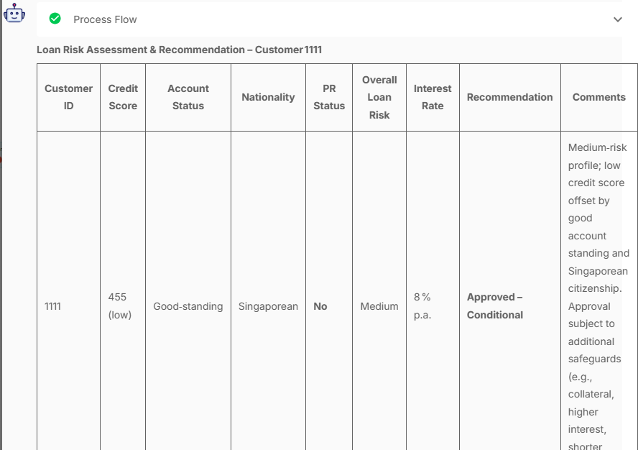
Comments: Medium-risk profile; low credit score offset by good account standing and Singaporean citizenship. Approval subject to additional safeguards (e.g., collateral, higher interest, shorter tenure).
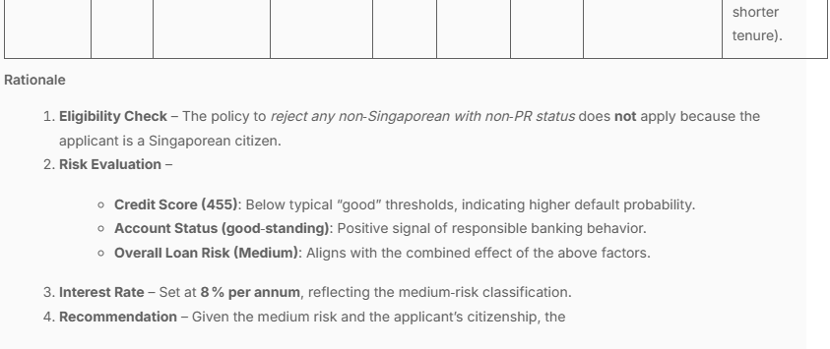

Customer 2222:
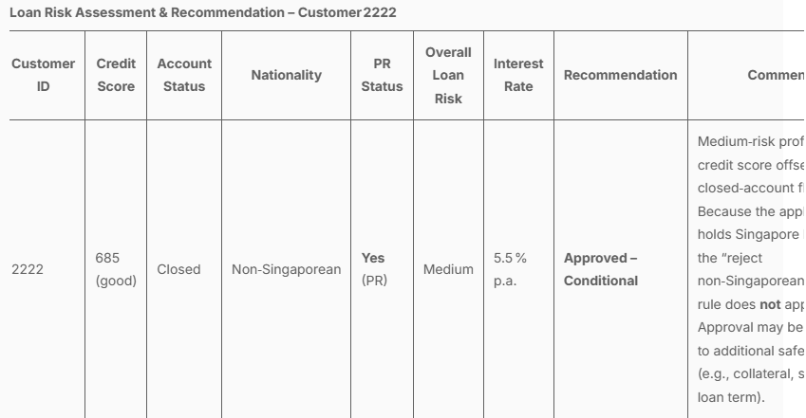
Comments: Medium-risk profile; solid credit score offsets the closed-account flag. Because the applicant holds Singapore PR status, the “reject non-Singaporean + non-PR” rule does not apply. Approval may be subject to additional safeguards (e.g., collateral, shorter loan term).
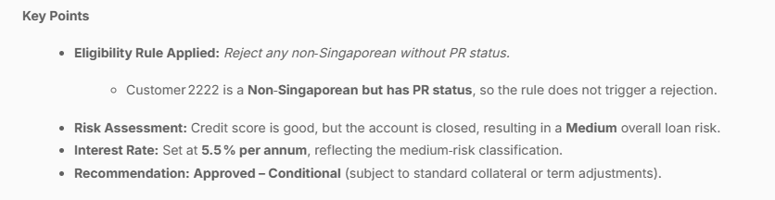

Customer 3333:
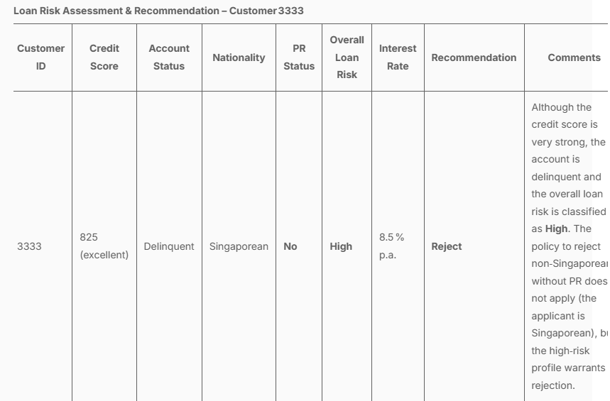
Comments: Although the credit score is very strong, the account is delinquent and the overall loan risk is classified as High. The policy to reject non-Singaporeans without PR does not apply (the applicant is Singaporean), but the high-risk profile warrants a rejection.
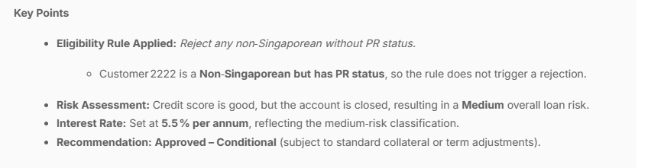
Customer 4444:
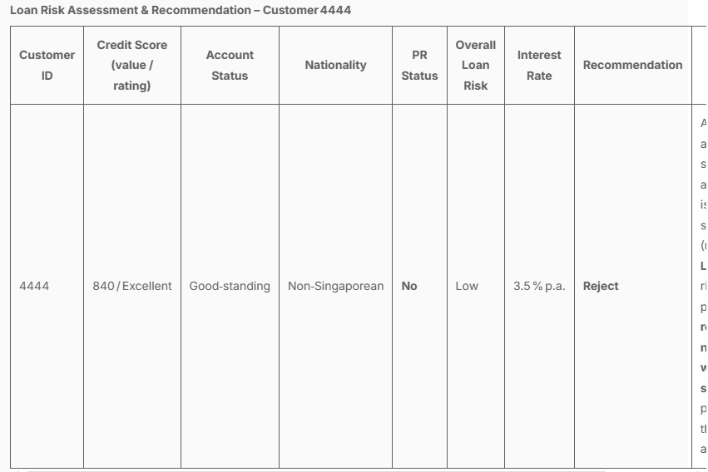
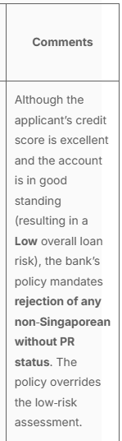
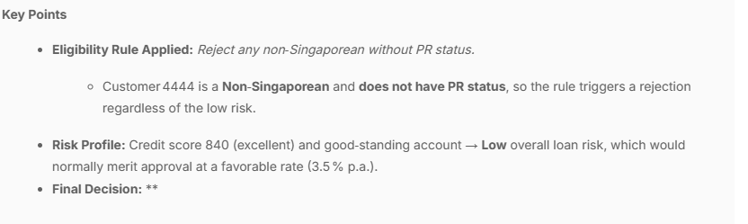
Customer 5555:

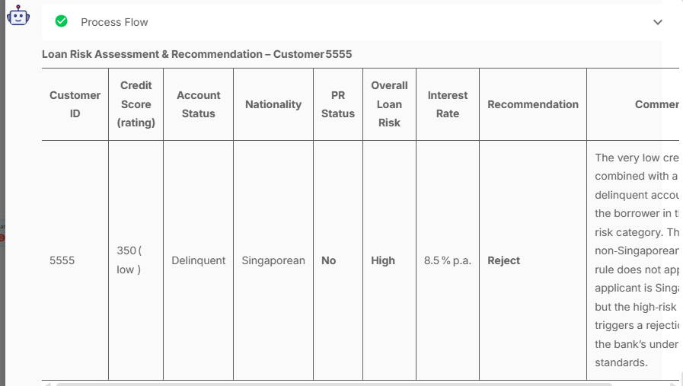
Comments: The very low credit score combined with a delinquent account places the borrower in the High risk category. The “reject non-Singaporean + non-PR” rule does not apply (the applicant is Singaporean), but the high-risk rating triggers a rejection under the bank’s underwriting standards.
Customer 9999:
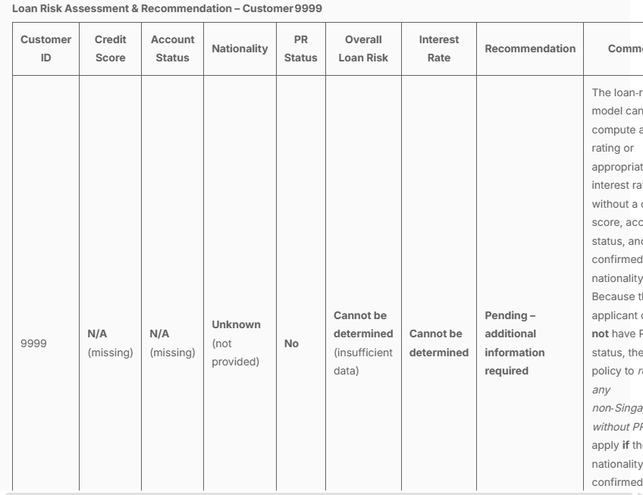
Comments: The loan-risk model cannot compute a risk rating or appropriate interest rate without a credit score, account status, and confirmed nationality. Because the applicant does not have PR status, the bank’s policy to reject any non-Singaporean without PR would apply if the nationality is later confirmed as non-Singaporean. Until the missing data are supplied, the application remains pending.
